

Launch a measurement campaign
(User Manual)
Connected data logger

Table of Contents
Step 0: System setup 3
Step 1: Check that the measurement node is in write mode 4
Step 2: Powering nodes 5
Step 3: Start measurement 6
Step 4: Access data 7
Step 5: Stop measurement 7
Step 6: Download data 8

Step 0: System setup

First, install the various system nodes in open areas to ensure that the solar panels can face the sun. The measurement node should be placed close to the ground to allow the soil moisture sensor to be properly inserted. The sensor box should be oriented to prevent water from entering. Ensure that the PVC boxes contain all the necessary equipment and are consistent with the electrical diagram. Also, confirm that the nodes are not powered; the cable connected to the Lipo charger’s OUT pin should be disconnected.

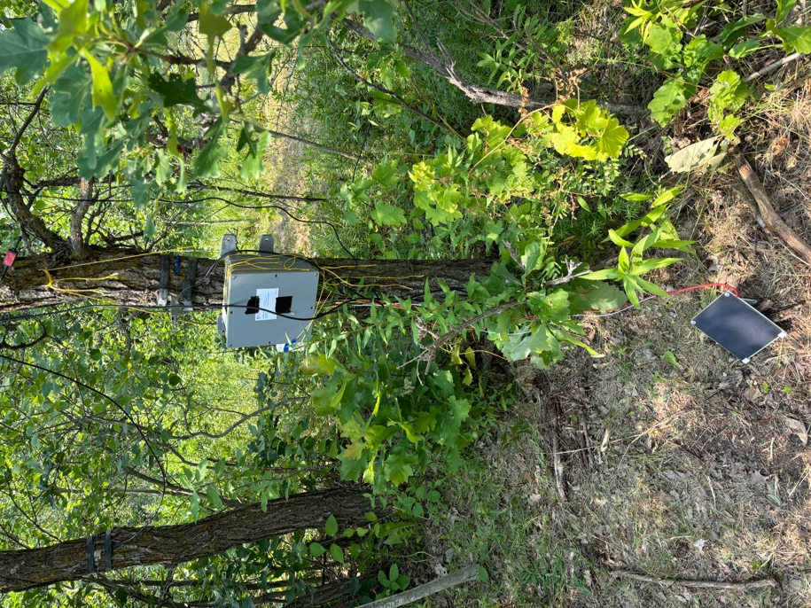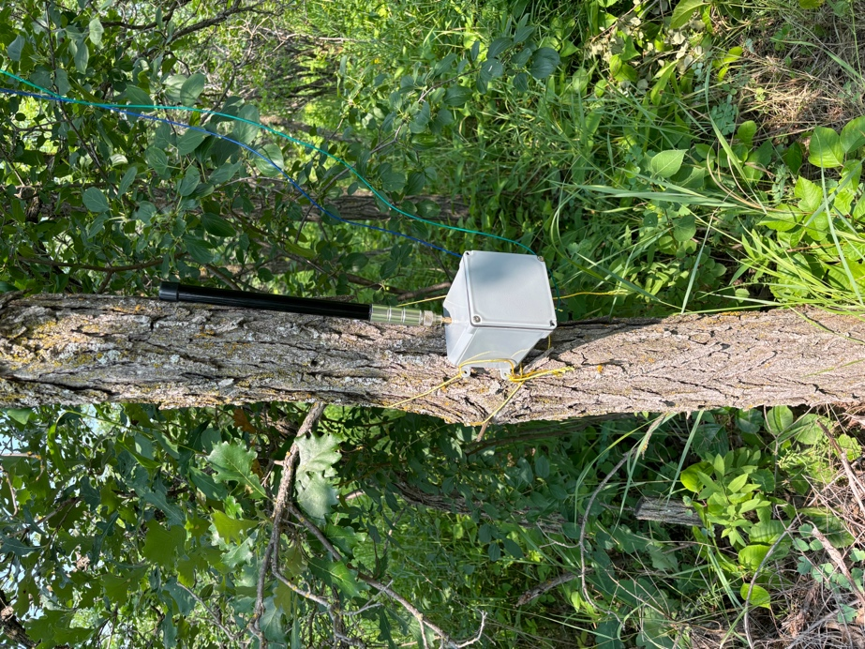
Figure 1 : Measurement node Figure 2 : Main node

Step 1: Check that the measurement node is in write mode

The RP2040 does not allow code changes while it is storing data in its memory. Therefore, you must ensure that the board is in write mode for the measurement data to be recorded correctly.
- Connect your computer to the measurement node board using a USB-C cable.
- If the connection is successful, a “CIRCUITPY” storage drive should appear in your folders.
- Open the “CIRCUITPY” drive. If the device is in write mode, a “boot.py” file should be present. If not, rename “boot.bak” to “boot.py”.
- Disconnect the cable.

Step 2: Powering nodes

First, power up the main node by connecting the power cable to the OUT pin on the Lipo charger. A small green LED on the RP2040 should flash for one second, and several LEDs on the 4G board should light up.
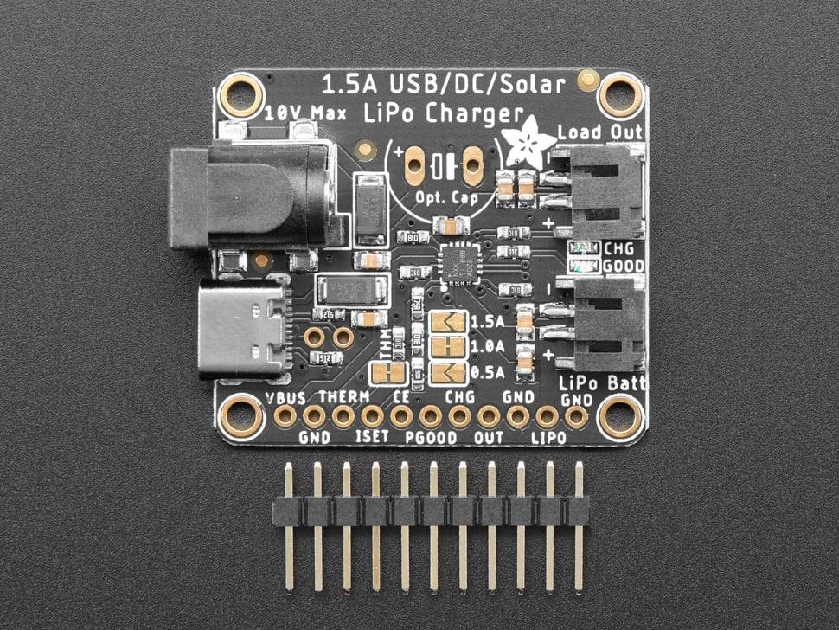
Figure 3 : USB/DC/Solar LiPo Charger

Next, power up the measurement node in the same manner. The RP2040 LED should flash green for a second, and the OLED display should light up, showing two sentences.
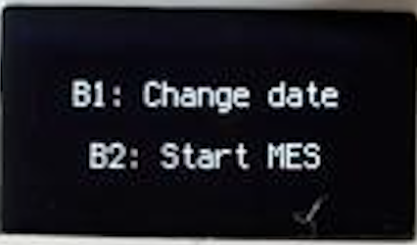
Figure 4 : Power up screen

Step 3: Start measurement

To initiate a measurement campaign, you need to update the module’s time. Press button 1 to begin.
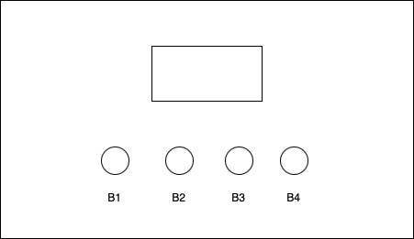
Figure 5 : Measurement node cover diagram

- Set the hour, minute, and second using buttons B1, B2, and B3. Each press increments the corresponding parameter by 1.
- Press button B4 to switch to date setting mode, then use B1, B2, and B3 to adjust the year, month, and day.
- Press B4 again to confirm the date and time. The time should be in 24-hour format and the date in YYYY/MM/DD format.
- If the configuration time has not elapsed, you should return to the main menu. A configuration time of 60 seconds has been set in the code to automatically launch a measurement campaign if no other action is taken, preventing the board from getting stuck in the selection menu after a reboot.
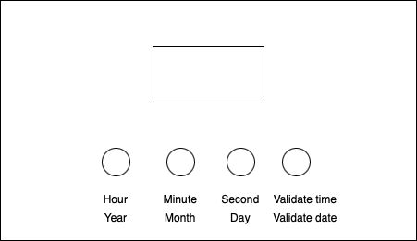
Figure 6 : Representation of buttons functionalities

From the mode selection menu, press B2 to start the measurement campaign. The screen should then go completely black.

Step 4: Access data

If the configuration was completed correctly and the measurement campaign has started, you should find the data on the ThingSpeak channel specified in the code.
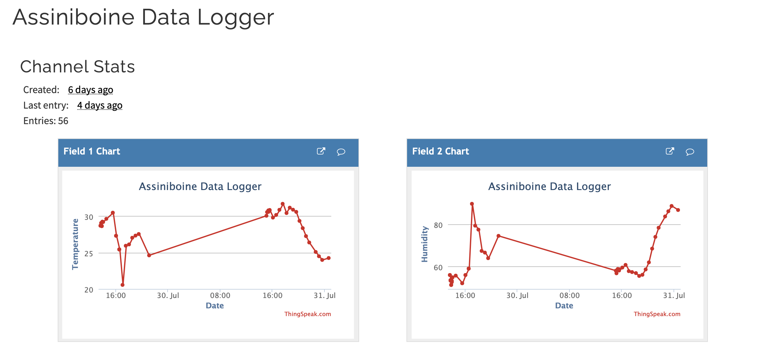
Figure 7 : Example of a ThingSpeak channel
Data will be sent every 30 minutes, or at another interval if defined otherwise. To ensure the system is working properly, measurements will be taken at the start of the campaign and sent to the ThingSpeak channel.

Step 5: Stop measurement

To stop the measurement campaign, press B4. A confirmation message should appear. If you wish to stop the measurements, press B4 again; otherwise, wait for the confirmation to disappear.
If the measurement campaign ends successfully, an error should appear on the screen. This indicates that the board no longer has write access and has entered error mode.

Step 6: Download data

To increase system reliability, data is stored in three different locations:
- ThingSpeak Channel: This provides live data visualization and the ability to download data in CSV format. The channel owner can export data by going to the Data Import/Export tab and using the export function. 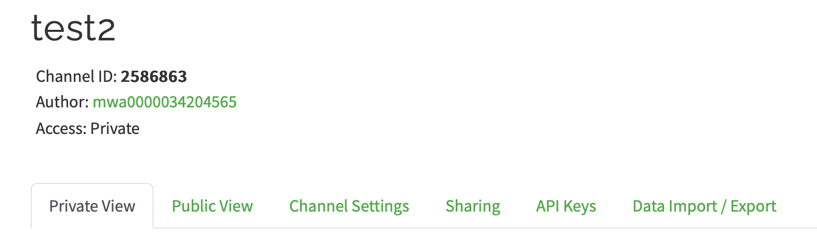
Figure 8 : All the panels in a ThingSpeak channel

- Measurement Node: In case of data transmission failure, the data will be saved in a CSV file directly on the measurement node. The file will be named after the start date of the measurement campaign.
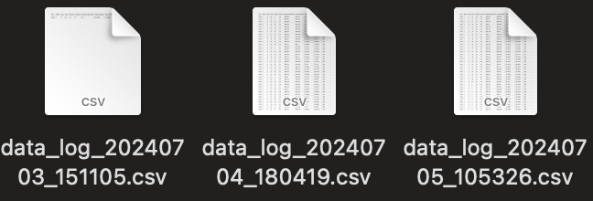
Figure 9 : CSV files in measurement node

- SD Card on the 4G Board: If 4G transmission fails, the data will still be accessible on the SD card. The data will be saved in CSV format, and the file will be named according to the measurement node number.
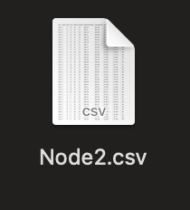
Figure 10 : CSV file in 4G board

